Module | WSQ- Business Analytics (SF)
Name | Koh Chun Yao
Date | 11 Feb 2026

Assignment-1a Submission

Task 1 - IMPORT DATA

Provide screenshot of Imported table, make sure your screenshot contains the table loaded from products.csv.

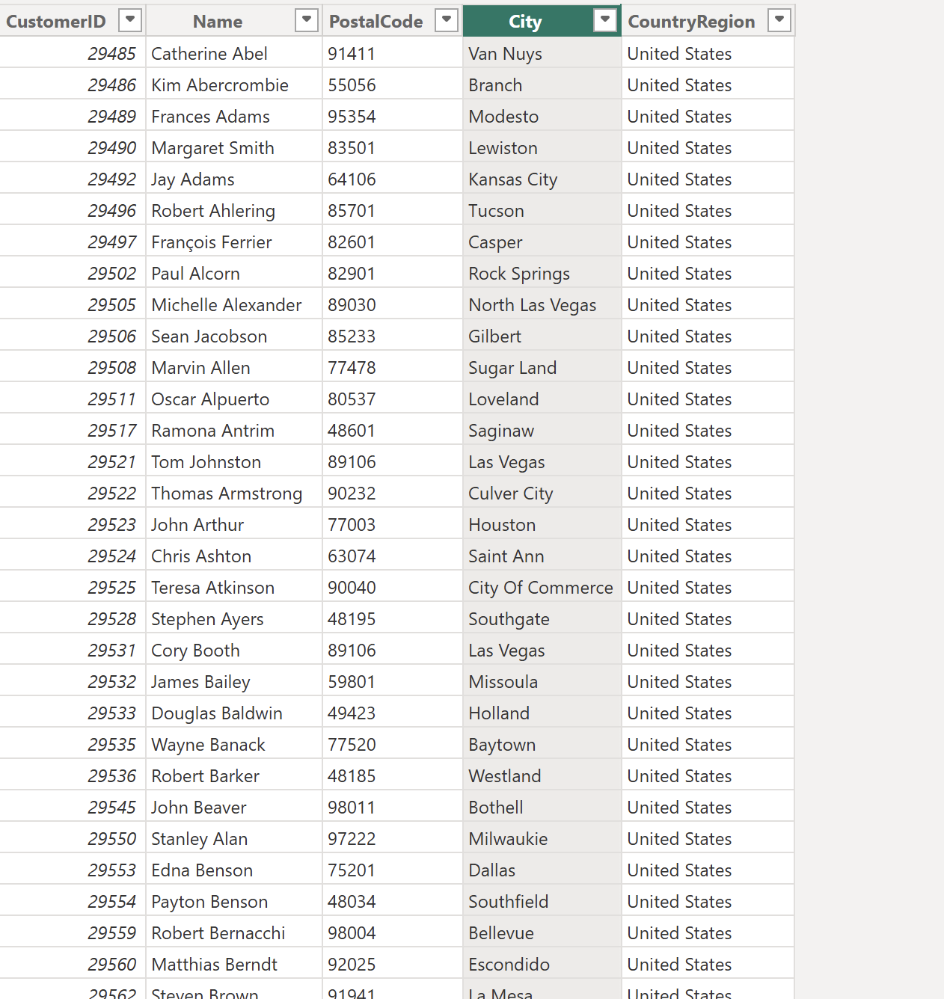

Task 2 - EXPLORE A DATA MODEL

Provide screenshot of Data model, the screenshot should contain all the interrelationships between tables.

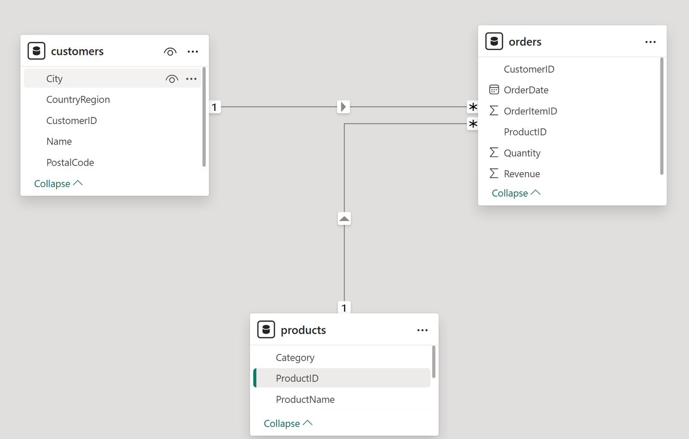
Task 3 - CREATE A REPORT

Provide screenshot of your Report, make sure screenshot includes all the visualizations in the report.

